1. **SoftBlog**

### Use the Given Skeleton to Solve This Problem.

**Note: You Have NO Permission to Change Directly the Given HTML (Index.html File).**

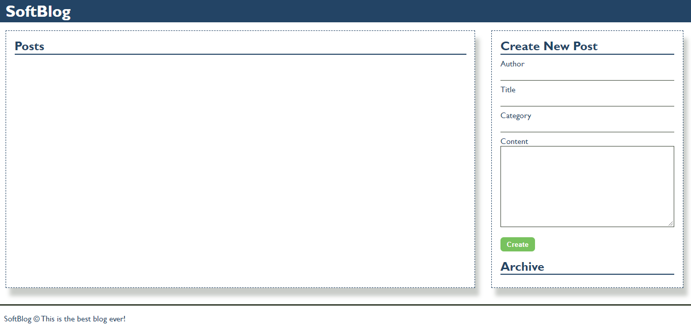

### Your Task

Write the missing JavaScript code to make the Blog application work as expected.

You should be able to **create** new articles.

Each article has **name, title, category** and **content**. When you click the **[Create]** button, a new **article item** should be added to the articles **section**.

The new item should have the **following structure**:

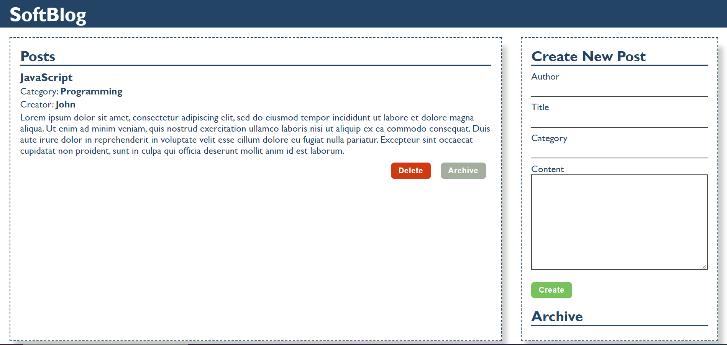

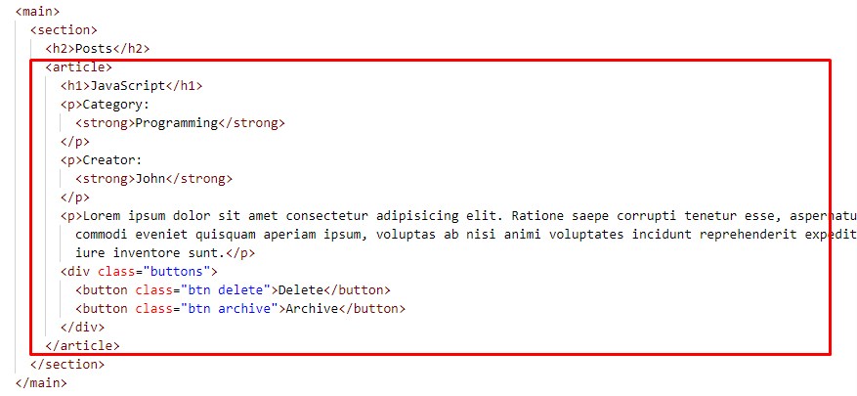

* Append two buttons, which are in a **div** element with class **"buttons"** to each article item
  + **[Delete]** button should have the following classes: **"btn" and "delete"**
  + **[Archive]** button should have the following classes: **"btn" and "archive"**

When you click the **[Archive]** button you should move the article to the **ol** in the archive section. Archive section should be **sorted by title**.

**Important! Do not move the entire article, but only the title of the article.**

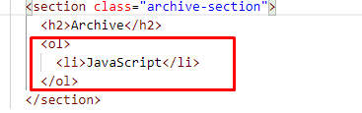

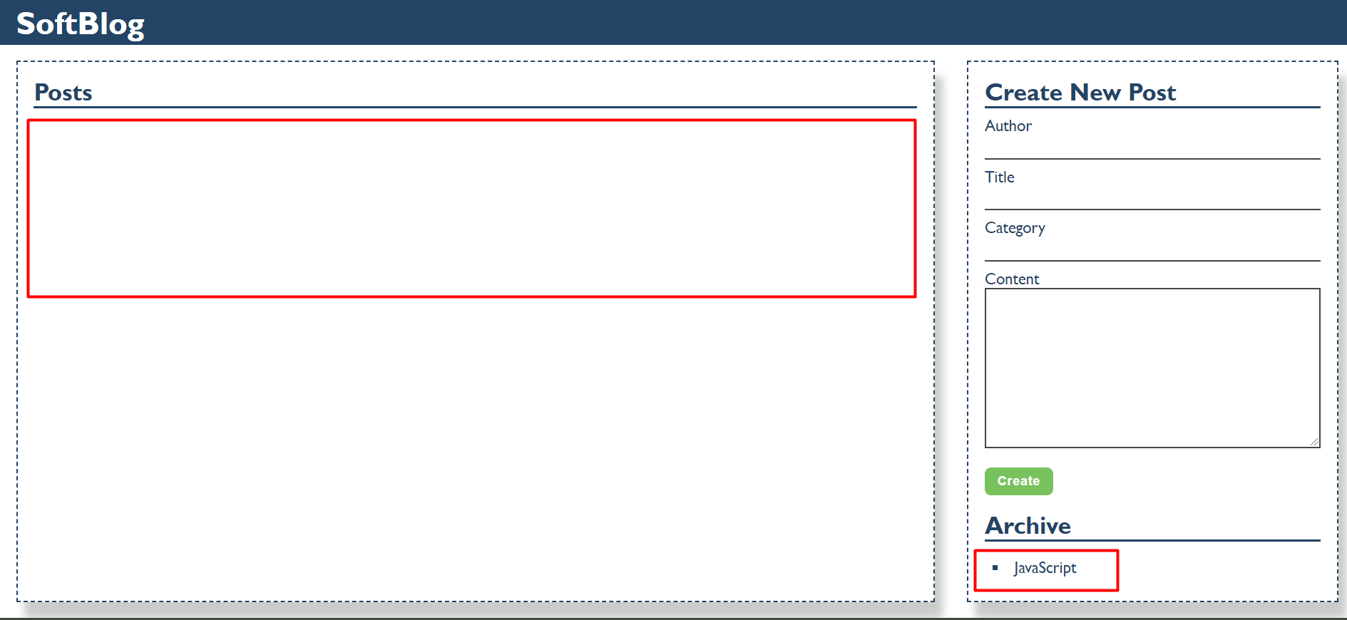

When you click the **[Delete]** button you should delete the entire article.

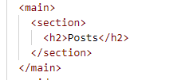

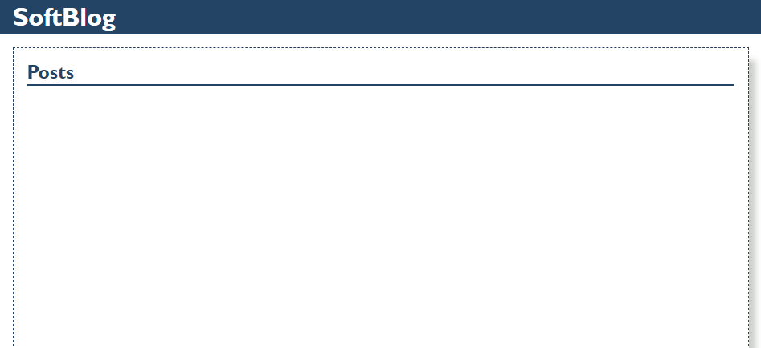

function solve() {

    let sectionEl = document.querySelector('main > section')

    let creatorEl = document.getElementById('creator')

    let titleEl = document.getElementById('title')

    let categoryEl = document.getElementById('category')

    let contentEl = document.getElementById('content')

    let btnEl = document.getElementsByTagName('button')[0]

    let archiveOlEl = document.getElementsByTagName('ol')[0]

    btnEl.addEventListener('click', e => {

        e.preventDefault()

        let title = titleEl.value;

        let btn1El = document.createElement('button')

        btn1El.classList.add('btn')

        btn1El.classList.add('delete')

        btn1El.textContent = 'Delete'

        let btn2El = document.createElement('button')

        btn2El.classList.add('btn')

        btn2El.classList.add('archive')

        btn2El.textContent = 'Archive'

        let divEl = document.createElement('div')

        divEl.classList.add('buttons')

        divEl.appendChild(btn1El)

        divEl.appendChild(btn2El)

        let h1El = document.createElement('h1')

        h1El.textContent = titleEl.value;

        let p1El = document.createElement('p')

        p1El.innerHTML = `Category: <strong>${categoryEl.value}</strong>`

        let p2El = document.createElement('p')

        p2El.innerHTML = `Creator: <strong>${creatorEl.value}</strong>`

        let p3El = document.createElement('p')

        p3El.textContent = contentEl.value;

        let articleEl = document.createElement('article')

        articleEl.appendChild(h1El)

        articleEl.appendChild(p1El)

        articleEl.appendChild(p2El)

        articleEl.appendChild(p3El)

        articleEl.appendChild(divEl)

        sectionEl.appendChild(articleEl)

        btn1El.addEventListener('click', e => {

            articleEl.remove()

        })

        btn2El.addEventListener('click', e => {

            let liEl = document.createElement('li')

            liEl.textContent = title

            archiveOlEl.appendChild(liEl)

            let allLis = Array.from(archiveOlEl.children);

            allLis.sort((a, b) => a.textContent.localeCompare(b.textContent)).forEach(li => {

                archiveOlEl.appendChild(li)

            })

            articleEl.remove()

        })

    })

}

#### Мое решение:

function solve() {

   const section = document.querySelector('main section');

   const form = document.querySelector('form');

   form.addEventListener('submit', (event) => {

      event.preventDefault();

      const creator = document.querySelector('input[name="creator"]').value;

      const title = document.getElementById('title').value;

      const category = document.getElementById('category').value;

      const content = document.getElementById('content').value;

      const article = document.createElement('article');

      const h1 = document.createElement('h1');

      h1.textContent = title;

      const pCat = document.createElement('p');

      pCat.textContent = 'Category:';

      const strongCategory = document.createElement('strong');

      strongCategory.textContent = category;

      pCat.appendChild(strongCategory);

      const pCreat = document.createElement('p');

      pCreat.textContent = 'Creator:';

      const strongCreator = document.createElement('strong');

      strongCreator.textContent = creator;

      pCreat.appendChild(strongCreator);

      const pCont = document.createElement('p');

      pCont.textContent = content;

      const div = document.createElement('div');

      //Delete

      div.className = "buttons";

      const btnDelete = document.createElement('button');

      btnDelete.className = "btn delete";

      btnDelete.textContent = "Delete";

      btnDelete.addEventListener('click', btnOnDelete)

      //Archive

      const btnArchive = document.createElement('button');

      btnArchive.className = "btn archive";

      btnArchive.textContent = "Archive";

      btnArchive.addEventListener('click', btnOnArchive)

      div.appendChild(btnDelete);

      div.appendChild(btnArchive);

      article.appendChild(h1);

      article.appendChild(pCat);

      article.appendChild(pCreat);

      article.appendChild(pCont);

      article.appendChild(div);

      section.appendChild(article);

   });

}

function btnOnDelete(event) {

   const article = event.target.parentNode.parentNode;

   article.remove();

};

function btnOnArchive(event) {

   const articleTextCotent = event.target.parentNode.parentNode.querySelector('h1').textContent;

   const li = document.createElement('li');

   li.textContent = articleTextCotent;

   let ol = document.querySelector('ol');

   ol.appendChild(li);

   let titles = Array.from(ol.children);

   titles.sort((a, b) => a.textContent.localeCompare(b.textContent)).forEach(li=>ol.appendChild(li));

   btnOnDelete(event);

};

Мое решение :

function solve() {

   const name = document.getElementById('creator');

   const title = document.getElementById('title');

   const category = document.getElementById('category');

   const content = document.getElementById('content');

   const olArchiveElements = document.querySelector('ol');

   const createBtn = document.querySelector('form button');

   createBtn.addEventListener('click', createArticle);

   function createArticle(event) {

      event.preventDefault();

      //article

      const article = document.createElement('article');

      //h1

      const h1 = document.createElement('h1');

      h1.textContent = title.value;

      //category

      const pCat = document.createElement('p');

      pCat.textContent = 'Category: '

      const strongCat = document.createElement('strong');

      strongCat.textContent = category.value;

      pCat.appendChild(strongCat);

      //creat

      const pCreat = document.createElement('p');

      pCreat.textContent = 'Creator: '

      const strongCreat = document.createElement('strong');

      strongCreat.textContent = name.value;

      pCreat.appendChild(strongCreat);

      //cont

      const pCont = document.createElement('p');

      pCont.textContent = content.value;

      //div with buttons

      const deleteBtn = document.createElement('button');

      deleteBtn.classList.add("btn");

      deleteBtn.classList.add("delete");

      deleteBtn.textContent = 'Delete';

      deleteBtn.addEventListener('click', deleteContet);

      const archiveBtn = document.createElement('button');

      archiveBtn.classList.add("btn");

      archiveBtn.classList.add("archive");

      archiveBtn.textContent = 'Archive';

      archiveBtn.addEventListener('click', archiveContent);

      const divButtons = document.createElement('div');

      divButtons.classList.add("buttons");

      divButtons.appendChild(deleteBtn);

      divButtons.appendChild(archiveBtn);

      article.appendChild(h1);

      article.appendChild(pCat);

      article.appendChild(pCreat);

      article.appendChild(pCont);

      article.appendChild(divButtons);

      document.querySelectorAll('section')[1].appendChild(article);

   };

   function deleteContet(event) {

      event.target.parentNode.parentNode.remove();

   }

   function archiveContent(event) {

      const article = event.target.parentNode.parentNode;

      const titleTextContent = article.children[0].textContent;

      article.remove();

      const li = document.createElement('li');

      li.textContent = titleTextContent;

      olArchiveElements.appendChild(li);

      sortArchiveElements(olArchiveElements);

   }

   function sortArchiveElements(htmlCollection) {

     Array.from(htmlCollection.children)

     .sort((a, b) => a.textContent.localeCompare(b.textContent))

     .forEach(li=>htmlCollection.appendChild(li));

   }

}